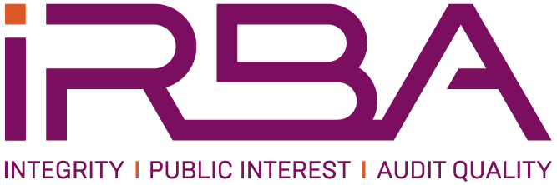

NOMINATION FOR STATUTORY COMMITTEES
CANDIDATE INFORMATION
NOMINATION FOR THE COMMITTEE FOR AUDITING STANDARDS (CFAS)
Position for which the nomination is being submitted, per Section 22(1) of the Auditing Profession Act, as amended
CANDIDATE DETAILS
Full names
Gender
Race
Address 1
Address 2
Telephone number
Email address
Nationality
Language
Country of residence
Professional designation
Professional affiliation(s)
Prior IRBA involvement:
- Committee(s)
- Term(s) served
Present occupation
Educational background
Professional experience
Appointments/activities/experience in auditing standards and auditing standard setting, as well as in related technical aspects
Why do you wish to be appointed to this position?
What would be your objectives as a member of this committee?
Explain how your skills, knowledge and experience are relevant to this position
Has there been any disciplinary action against you by accounting or other professional bodies, regulators or others?
If yes, please provide the details.
Will you be able to meet the time commitments indicated for members on this committee?
Nominating organisation (if applicable)
Contact person at the nominating organisation
Contact details of the abovementioned person:
- Telephone number
- Cellphone number
- Email address

Please submit your completed Nomination Form to ivanker@irba.co.za or sadam@irba.co.za
by no later than 8 January 2025.
Thank you for your submission.

Information required to ensure a balance in gender representation on the CFAS.
Information needed to ensure a balance in demographic representation on the committee.

