
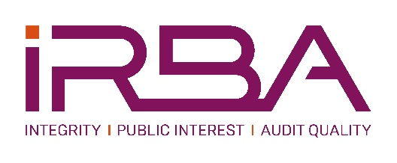

APPLICATION AND/OR NOMINATION FORM
EDUCATION, TRAINING AND PROFESSIONAL DEVELOPMENT COMMITTEE (EDCOM)

NOMINATION POSITION | EDCOM MEMBER
Candidate information
Full names
Surname
Gender*
Race*
Address 1
Address 2
Town / City
Telephone Mobile number
Telephone Landline (or alternate number)
E-mail
Alternate E-Mail
Nationality
Language
Country of residence
Professional designation/s
Prior or current PAAB/IRBA involvement
- Committees
- Terms served
(The PAAB is the IRBA’s predecessor body)
Prior or current involvement with SAICA and/or ACCA (to assess experience and conflicts of interest)

Educational background
(Kindly also indicate highest qualification and submit the certificate with the application)

Professional experience
Experience in academia (Years and roles). Please specify any experience in the delivery of the ACCA programme. and/or
Experience relating to training and development of RAs within an auditing firm. Please specify any experience in the training and development of trainees on the ACCA programme.

Appointments/activities/experience in:
- Accreditation and monitoring of professional bodies/organisations;
- Training management experience at an auditing firm;
- Educational psychology;
- Competency model development and/or implementation;
- Professional development in a corporate role;
- Professional development in other industries;
- Strategic knowledge and experience; and
- Transformation strategy implementation.
Explain why you wish to be a member of the IRBA EDCOM.

Explain how your skills, knowledge and experience are relevant to this position.

Has there been, or are there any disciplinary actions (or ongoing investigations) against you by accounting or other professional bodies, regulators, employers or others? If yes, please describe.

Will you be able to meet the time commitments for the IRBA EDCOM?
(About 4 meetings per annum and preparation and report reviews for these meetings)

* This information is required to ensure gender and demographic representivity on the IRBA.

Please submit your completed Nomination Form, your CV, certificate of highest qualification and motivation to:
nkater@irba.co.za and cc mmoola@irba.co.za.
By no later than the date noted on the advert.

THANK YOU FOR YOUR SUBMISSION

